Object- To estimate the amount of Ferrous ammonium sulphate using standard potassium dichromate potentiometrically

**Apparatus and Materials Required:**

1. Potentiometer
2. Platinum electrode (indicator electrode)
3. Calomel or Silver/Silver Chloride electrode (reference electrode)
4. Burette (50 mL)
5. Pipette (10 mL)
6. Volumetric flask (100 mL)
7. Beaker (250 mL)
8. Magnetic stirrer with stir bar
9. Wash bottle
10. Funnel
11. Glass rod

**Theory:** Using a suitable electrode that reacts to the concentration change during the titration, one can quantify the change in potential in a potentiometric titration. An indicator electrode is an electrode that reacts to a change in the amount of ions present in the solution. The reference electrode, whose potential remains constant during the titration, is paired with the indicator electrode to create a cell. The cell's e.m.f. varies gradually up until the end point, then quickly right before it and again gradually after. The first derivative curve is plotted against V, the peak of which is (∆E/∆V).   
  
The titration's end point is indicated by the curve.

.  
 3Fe2+ + Cr6+ → 3Fe3+ + Cr3+ [Acidic medium]

The potentiometric titration of FAS (Mohr’s salt) solution with K2Cr2O7 in the presence of H2SO4 is a redox titration. An oxidation-reduction electrode forms when the same material is present in both its reduced and oxidized forms in a solution. This electrode potential can be detected by dipping a platinum wire into the solution. Because of this, the solution contains both Fe2+ and Fe3+ ions when the titration is started, creating an electrode potential that a Pt wire detects. The indicator electrode, then, is (Pt/Fe3, Fe2+), and its electrode potential is provided by,

E=E0 + 2.303 RT log (Fe3+)/ nF (Fe2+)

**Procedure**

**Preparation of Solutions:**

1. **Preparation of Standard Potassium Dichromate Solution:**Dissolve an accurately weighed amount of Potassium Dichromate (K₂Cr₂O₇) in distilled water and dilute to 1000 mL in a volumetric flask to make a 0.1 N solution.
2. **Preparation of Ferrous Ammonium Sulfate (FAS) Solution:**Weigh accurately about 3.92 g of FAS, dissolve in a minimum amount of distilled water, add 10 mL of dilute H₂SO₄, and dilute to 100 mL in a volumetric flask.

Process

* Connect the potentiometer to the indicator electrode (platinum electrode) and the reference electrode (calomel or silver/silver chloride electrode).
* Place the electrodes in the beaker containing the FAS solution
* Transfer 25 centiliters of ferrous ammonium sulphate using a pipette into a beaker. Pour in two test tubes filled with diluted sulfuric acid.
* Put the platinum electrode assembly and calomel inside of it.
* Measure the potential by connecting the platinum and calomel electrode to a potentiometer.
* Add o.5 N potassium dichromate solution to the burette.
* To the beaker, add 0.5 cm3 of potassium dichromate.
* Mix the mixture and record the potential.   
  Proceed with the process until the potential exhibits a tendency to rise quickly.
* Add potassium dichromate now, measuring the potential after each addition in 0.5 cm3 increments.
* Plot the equivalency point of ∆E/∆V against the volume of potassium dichromate to create a graph.
* Calculate the normality and weight of ferrous ammonium sulphate in the given solution.

In a potentiometric titration, the graph obtained is a plot of **Electrode Potential (E)** versus **Volume of Potassium Dichromate (K₂Cr₂O₇) added (mL)**.

### **Type of Graph:**

1. **S-Shaped Curve (Sigmoidal Curve):**

The graph typically exhibits an S-shaped curve.Initially, the change in potential (E) is gradual as small volumes of the titrant (Potassium Dichromate) are added.Near the equivalence point, there is a sharp, steep increase in the potential, indicating the rapid consumption of the ferrous ions (Fe²⁺) by the dichromate ions (Cr₂O₇²⁻).After the equivalence point, the potential increases more slowly again and stabilizes, as excess Potassium Dichromate is added beyond the point of complete reaction.

1. **Inflection Point:**

The equivalence point corresponds to the inflection point of the S-shaped curve, where the change in potential with respect to the volume of titrant added is the greatest.

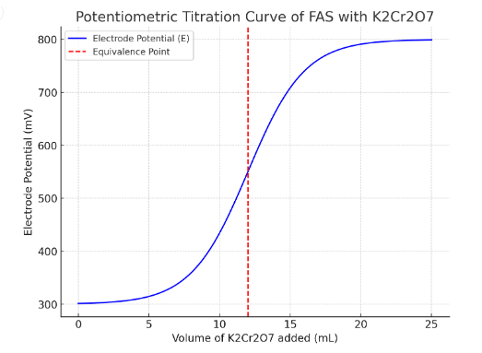

1. **First Derivative Plot (ΔE/ΔV vs. Volume):**

To more accurately determine the equivalence point, you can plot the first derivative of the potential change (ΔE/ΔV) versus the volume of titrant added.The equivalence point appears as a peak in this derivative plot.

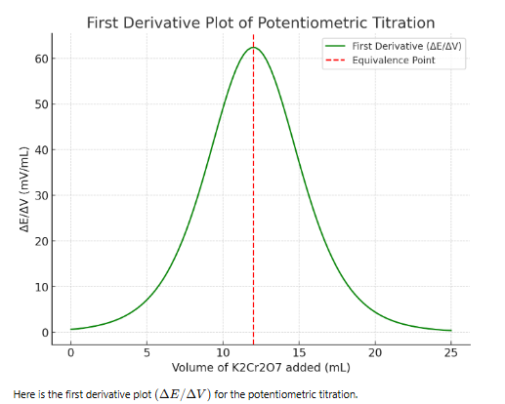

**Calculations:**

1. Plot a graph of electrode potential (E) vs. volume of Potassium Dichromate solution added (mL).
2. Identify the equivalence point from the point of inflection on the graph.
3. Calculate the concentration of the FAS solution using the equation:

Normality of FAS (N₁)=(​N2​×V2​​/V1)

N2​ = Normality of Potassium Dichromate solution

V2​ = Volume of Potassium Dichromate solution at equivalence point

V1​ = Volume of FAS solution

**Results**

**Strength of FAS= Normality x 392.1**

**Precautions:**

1. Ensure all glassware is clean and free of contaminants.
2. Use a freshly prepared solution of FAS to prevent oxidation of Fe²⁺ to Fe³⁺.
3. Handle all chemicals, especially sulfuric acid, with care, using appropriate safety equipment.
4. Record potential values accurately and allow sufficient time for stabilization after each addition of titrant.

Pre-Test Questions:

What is the primary purpose of using a potentiometer in a titration?

a) To measure temperature

b) To measure pH

c) To measure potential difference

d) To measure volume

Answer: c) To measure potential difference

Which of the following is the oxidizing agent in this titration?

a) Ferrous Ammonium Sulfate (FAS)

b) Sulfuric Acid (H₂SO₄)

c) Potassium Dichromate (K₂Cr₂O₇)

d) Water

Answer: c) Potassium Dichromate (K₂Cr₂O₇)

What is the function of sulfuric acid in the titration of FAS with Potassium Dichromate?

a) To act as an oxidizing agent

b) To maintain an acidic medium

c) To act as a reducing agent

d) To indicate the endpoint

Answer: b) To maintain an acidic medium

Which electrode is used as the reference electrode in potentiometric titration?

a) Glass electrode

b) Platinum electrode

c) Calomel or Silver/Silver Chloride electrode

d) Carbon electrode

Answer: c) Calomel or Silver/Silver Chloride electrode

The equivalence point in potentiometric titration is identified by:

a) The color change of the solution

b) The peak in the first derivative plot

c) The formation of a precipitate

d) The change in temperature

Answer: b) The peak in the first derivative plot

Post-Test Questions:

In a potentiometric titration, the S-shaped curve is due to:

a) A change in volume of the titrant

b) A change in temperature

c) A change in electrode potential

d) A change in pH

Answer: c) A change in electrode potential

Which point on the titration curve corresponds to the maximum rate of change in potential?

a) Initial point

b) End point

c) Equivalence point

d) Midpoint

Answer: c) Equivalence point

If a higher concentration of FAS is used, what happens to the volume of Potassium Dichromate needed to reach the equivalence point?

a) Increases

b) Decreases

c) Remains the same

d) Cannot be determined

Answer: a) Increases

What does the first derivative plot (ΔE/ΔV vs. volume) help determine in potentiometric titration?

a) The pH of the solution

b) The volume of the titrant used

c) The equivalence point

d) The temperature change

Answer: c) The equivalence point

One of the limitations of potentiometric titration is:

a) High accuracy

b) Sensitivity to temperature changes

c) Ability to use for colored solutions

d) Easy handling of equipment

Answer: b) Sensitivity to temperature changes